NATIONAL UNIVERSITY OF SCIENCES & TECHNOLOGY


Degree: MS-Bioinformatics
Department: School of Interdisciplinary Engineering & Sciences (SINES)
Submitted to: Dr. Masood Ur Rehman Kayani
Project No: 01

Student name: Mahreen Nawaz
Registration No. 533241
Subject: Next Generation Sequencing
Topic: Fastqc and fastp analysis on pair end samples SRR10613522 and SRR10613549
Submission Date: 24th October 2024

Preprocessing of the raw NGS data using FastQC and Fastp
Background: The project provided demand the preprocessing of paired end sequencing data by using FastQC and Fastp tools.
Steps:
- Visualization of the provided raw data via Fastqc tool.
- Preprocessing of the raw data via Fastp tool using default value settings.
- Visualizing the processed data again by Fastqc to recheck the quality of processed data.
- If there are still any errors or warnings in the data, it will be further processed using Fastp tool considering customized parameters accordingly.
- Final visualization of the processed data through Fastqc.
Sample SRR10613522:
The provided sample will be processed by the following above steps.
The paired end raw data (Sample SRR10613522) was visualized via fastqc tool and the graphs with errors and warnings are shown in Figure 1 & 2 having issues in Per base sequence quality, Per sequence GC content, and Overrepresented Sequences.
By preprocessing the data with default value setting of fastp the errors and warnings are significantly reduced as shown in Figure 3 & 4.
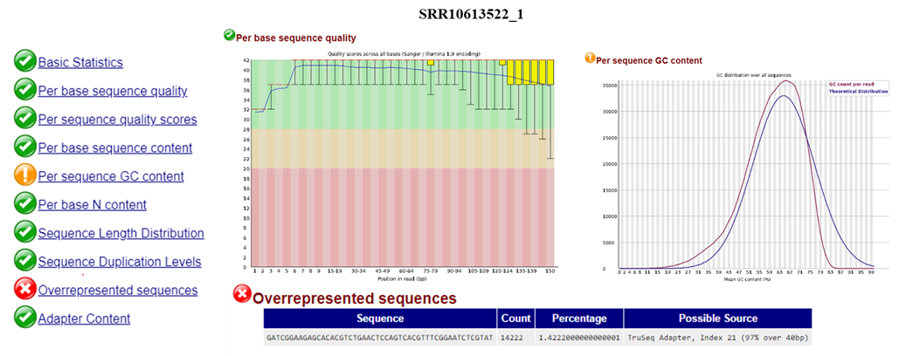
Figure 1 The initial visualization of Sample SRR10613522_1
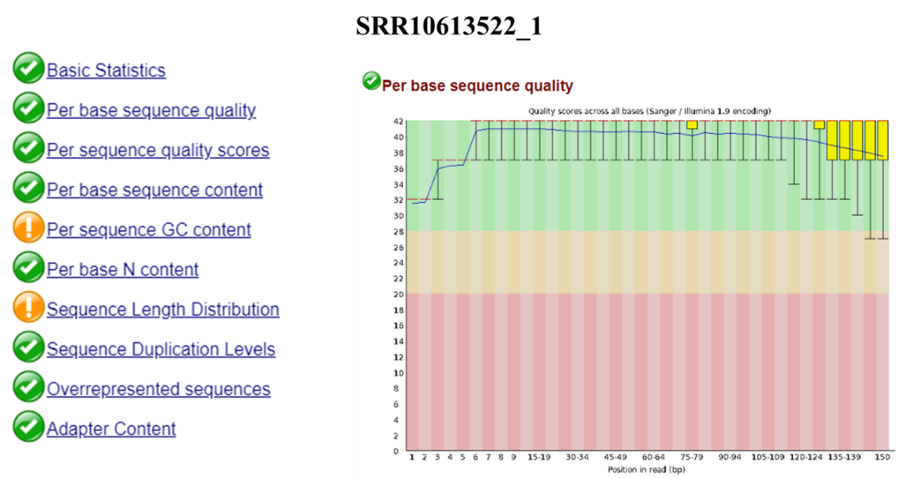
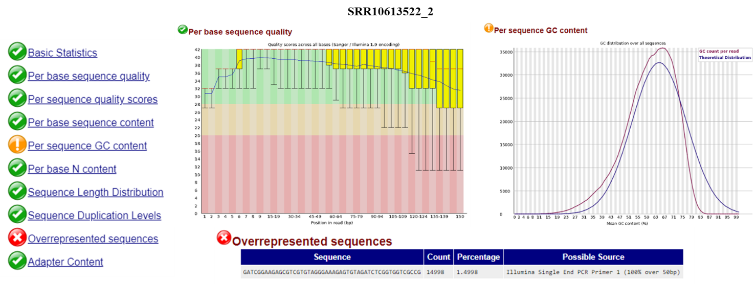
Figure 2 The initial visualization of Sample SRR10613522_2
Figure 3 Sample SRR10613522_1 after default fastp

Figure 4 Sample SRR10613522_1 after default fastp 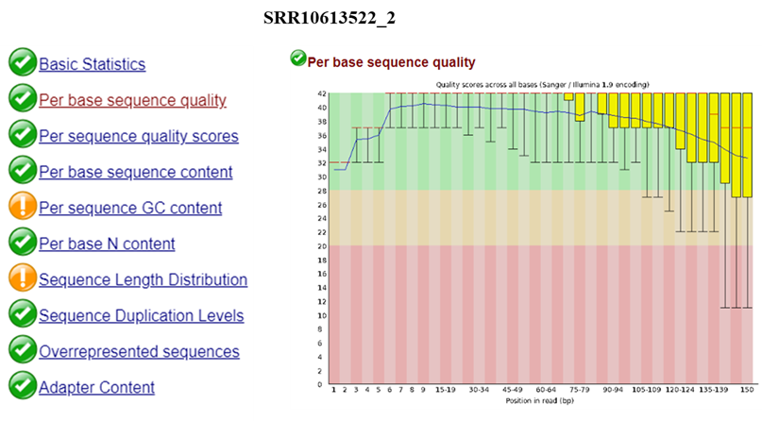
Sample SRR10613549
First the data were visualized using Fastqc to check for the red areas and warnings. The graphs are shown in Figure 5 and 6 having issues in per base sequence quality, per base sequence content per sequence GC content and overrepresented sequences.
By preprocessing the data with default value setting of fastp the errors and warnings still exist in the data.
Customized parameter of Fastp;
-f 15 for first read and -F for second read
Explanation of the flag;
-f is the is the option to trim bases from the 5' end (start) of each read in a sequencing dataset.
-f 15 means trim the first 15 bases from the 5' end of each read.
Reason:
I select this flag as there was issue in the per base sequence content and when I run this command the irregularity in the graphs of per base sequence quality and overrepresented sequences automatically reduced to a significant level which indicate that the bases removed with trimming seems to be poor quality bases causing troubles in the whole dataset. The warning in the per base sequence content also reduced and it shows green as showing in the Figure 7 and 8.

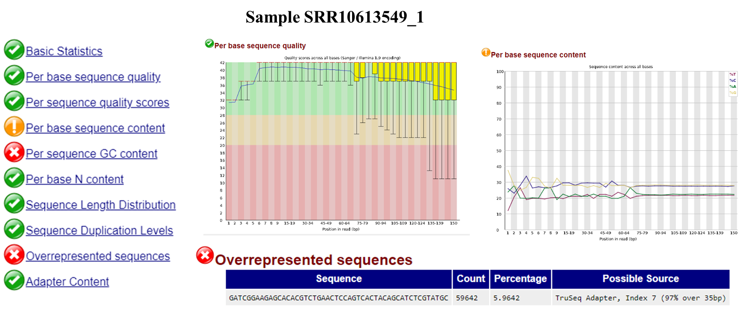
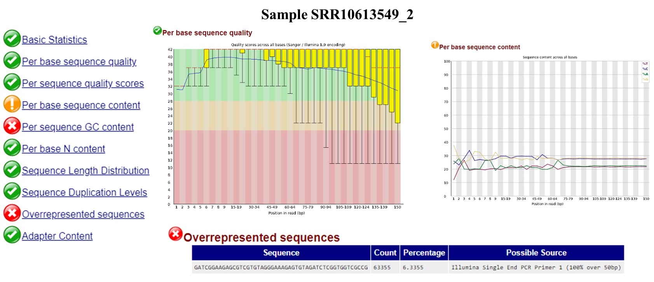
Figure 5 The initial visualization of Sample SRR10613549_1
Figure 6 The initial visualization of Sample SRR10613549_2

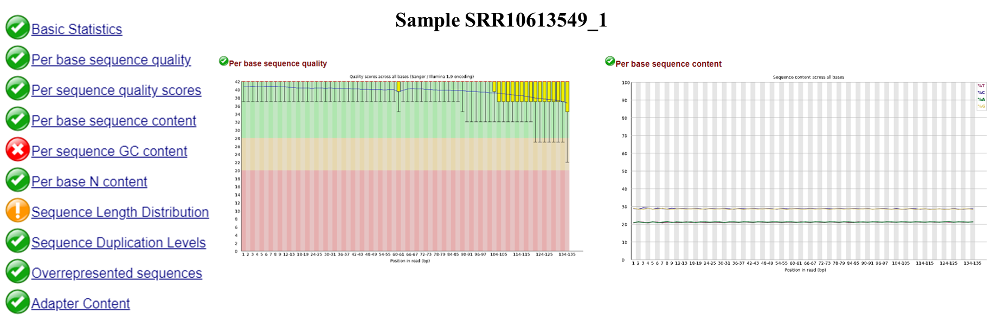
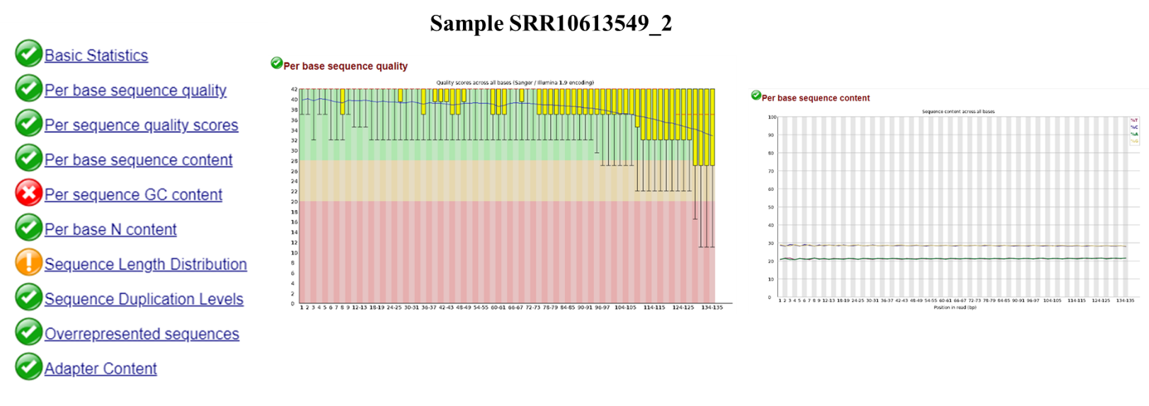
Figure 7 Results of Sample SRR10613549_1 after Customized Fastp
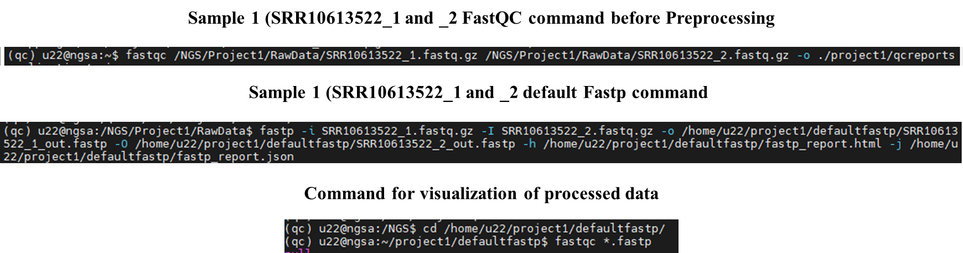
Figure 8 Results of Sample SRR10613549_1 after Customized Fastp
Figure 9 commands used for sample 1
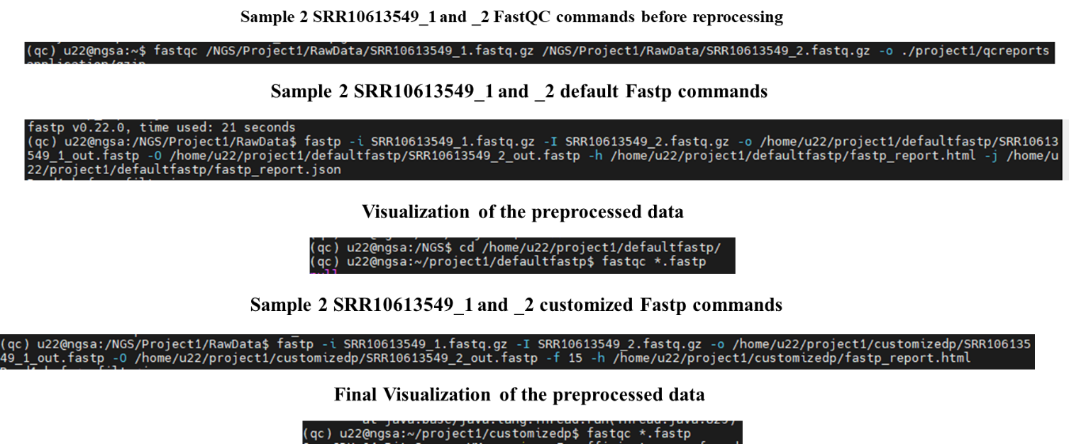
Figure 10 commands used for sample 1

